Name:

ID:

Submit here: <https://docs.google.com/forms/d/e/1FAIpQLSd2BNesKdm-0x9Lxcd4HregOJP0bT_TnX7QlLzWCUHmXGvnUg/viewform>

PART 1:

1. Consider the following:

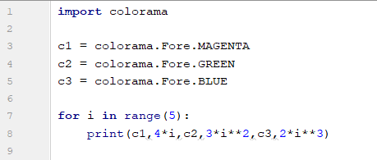

* Which color has the smallest value?

|  |  |
| --- | --- |
| magenta | green |
| blue | navy |
| black | white |

1. The following code generates the famous Collatz sequence. The sequence is started at any integer **n** and continued by dividing **n** by 2 if **n** is even, and multiply **n** by 3 and adding 1 if **n** is odd. A famous unsolved mystery in mathematics is whether or not there exists a value for n where the sequence will not reach 1.

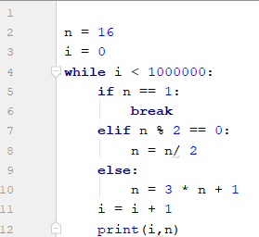

* What is the collatz sequence for n=20?

|  |  |
| --- | --- |
| 1,2,3,4,5,6,7 | 8,4,2,1 |
| 20,60,30,20,15,46,23,70,35,106,53,160,80,40,20,10,5,16,8,4,2,1 | 10,5,16,8,4,2,1 |
| 20,61,30,15,7,3,2,1 | 20,10,5,16,8,4,2,1 |
| 0,1,2,3,4,5,6,7 | 20,10,5,2,1 |

* How long is the collatz sequence for n = 33?

|  |  |
| --- | --- |
| 26 | 33 |
| 25 | 27 |
| 1 | 25 |
| 100 | 6 |

* Which of the following has the longest collatz sequence?

|  |  |
| --- | --- |
| 19 | 20 |
| 21 | 22 |
| 23 | 24 |
| 25 | 26 |
| 27 | 28 |
| 29 | 30 |

Part 2: [Lists: Part 2](https://runestone.academy/runestone/books/published/thinkcspy/Lists/intro-Lists.html)

1. Evaluate the following: (10.12)

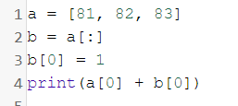

1. Evaluate the following: (10.13)

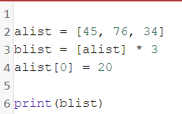

1. Evaluate the following: (10.13)

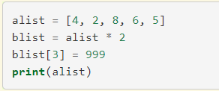

1. Evaluate the following: (10.14)

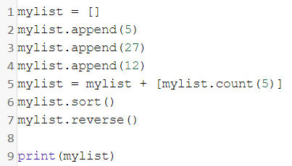

1. Evaluate the following: (10.14)

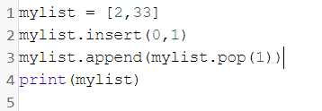

1. Consider the following: (10.17)

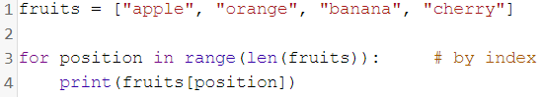

* What position is banana?